**COMSATS UNIVERSITY ISLAMABAD, ATTOCK CAMPUS**

**PROJECT REPORT 2019**



* **Project Title**

Reverse Direction of DC Motor Using Arduino UNO

* **Course**

Signal and System

* **Instructors**

Engr. M Abdul Rehman

Engr. Mubashir Rehman

* **Department**

Electrical Engineering

* **Group Members**

|  |  |
| --- | --- |
| **Name** | **Registration Number** |
|  |  |
|  |  |
|  |  |
|  |  |

TABLE OF CONTENTS

**ACKNOWLEDGEMENT**

**ABSTRACT**

**CHAPTER I**

**1.1 Introduction**

**CHAPTER II**

**2.1 Circuit Components**

**CHAPTER III**

**3.1.1 Circuit Schematic Diagram**

**3.1.2 Working Of Circuit Diagram**

**3.1.3 Index…………………………………………………………………….**

**3.1.4 Project Implementation……………………………………………………**

**CHAPTER IV**

**4.1** **FUTURE RECOMMENDATION**

**4.2** **CONCLUSION AND RESULTS……………………………………….**

**4.3** **REFERENCES**

**ACKNOWLEDGEMENT**

First of All, we thank to ALLAH Almighty, the Most Merciful, who gave us strength to complete this project. Then to our parents who support and encourage us.

We would like to thanks Sir Abdul Rehman and Sir Mubashir Rehman for their helpful guidance in this project. Throughout the semester, they provide their very valuable comments based on our output and put us back onto the right track. Without their inspiriting comments, this project would become very impractical for general use.

Last but not the least, we would like to thanks to all my friends and seniors who share their experiences with us.

**ABSTRACT**

The main aim of this project is to control the motion of dc motor and speed control of dc motor with an Arduino-UNO. This is a new technology to control direction of dc motor and speed control of dc motor. We control the motor manually which may cause manual errors. This system is enhanced to control the dc motor through an Arduino board. The proposed systems use an Arduino board and power supply.

**CHAPTER I**

**1.1 Introduction**

The L293D quadruple half-H drivers chip allows us to drive 2 motors in both directions, with two PWM outputs from the Arduino we can easily control the speed as well as the direction of rotation of one DC motor. (PWM: Pulse Width Modulation).

The speed of the DC motor (both directions) is controlled with the 10k potentiometer which is connected to analog channel 0 (A0) and the direction of rotation is controlled with the push button which is connected to pin 8 of the Arduino UNO board. If the button is pressed the motor will change its direction directly.

To control the direction of a DC motor, the polarity of the DC power applied to the motor’s connections must be reversed allowing its shaft to rotate in the opposite direction. One very simple and cheap way to control the rotational direction of a DC motor is to use different switches.

We will be using an Arduino to control the speed and direction of a DC Motor. For this, we will be using our DC Motor out there that falls within the peak voltage and current specifications of the H-Bridge we are using.

**CHAPTER II**

**2.1 Circuit Components**

* Arduino UNO board
* L293D driver
* DC motor
* 10K ohm potentiometer
* Pushbutton
* 12V source
* Veroboard
* Jumper wires

**Components Description:**

1. **Arduino Uno Board**

It is a microcontroller board which is an open-source electronics platform where anyone can modify and optimize the board based on the number of instructions and task they want to achieve, mainly based on AVR microcontroller Atmega328.

This board comes with a built-in regulation feature which keeps the voltage under control when the device is connected to the external device.

The current version of Arduino Uno comes with USB interface, 6 analogue input pins, 14 I/O digital ports that are used to connect with external electronic circuits. Out of 14 I/O ports, 6 pins can be used for PWM output.

* This board comes with all the features required to run the controller and can be directly connected to the computer through USB cable that is used to transfer the code.
* Arduino Uno comes with USB interface i.e. USB port is added on the board to develop serial communication with the computer.
* [Atmega328](https://www.theengineeringprojects.com/2017/08/introduction-to-atmega328.html) microcontroller is placed on the board that comes with a number of features like timers, counters, interrupts, PWM, CPU, I/O pins and based on a 16MHz clock that helps in producing more frequency and number of instructions per cycle.

Following figure shows the pinout of the Arduino Uno Board.

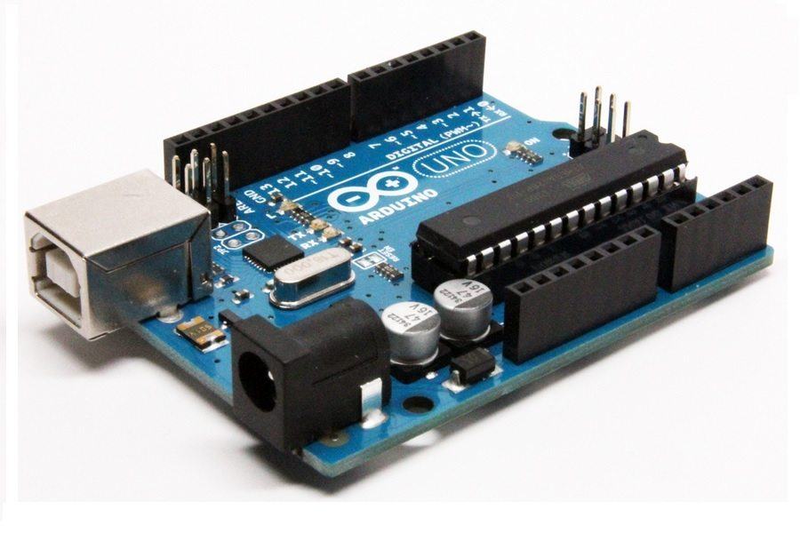

Arduino Uno R3 with ATmega328P (1)

1. **L293D driver**

L293D is a dual [H-bridge](http://www.engineersgarage.com/electronic-circuits/h-bridge-motor-control) motor driver integrated circuit (IC). Motor drivers act as current amplifiers since they take a low-current control signal and provide a higher-current signal. This higher current signal is used to drive the motors.

L293D contains two inbuilt H-bridge driver circuits. In its common mode of operation, two DC motors can be driven simultaneously, both in forward and reverse direction. The motor operations of two motors can be controlled by input logic at pins 2 & 7 and 10 & 15. Input logic 00 or 11 will stop the corresponding motor. Logic 01 and 10 will rotate it in clockwise and anticlockwise directions, respectively.

Enable pins 1 and 9 (corresponding to the two motors) must be high for motors to start operating. When an enable input is high, the associated driver gets enabled. As a result, the outputs become active and work in phase with their inputs. Similarly, when the enable input is low, that driver is disabled, and their outputs are off and in the high-impedance state.

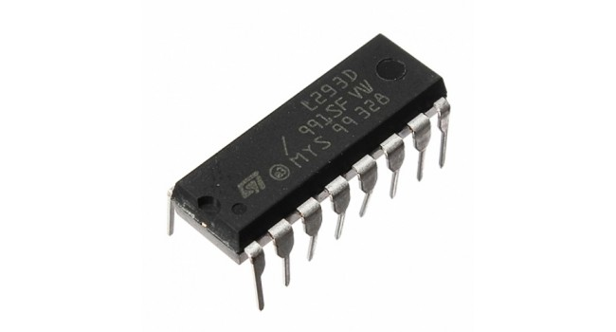

L293D Driver IC (2)

1. **DC Motor**

A DC motor is any of a class of rotary electrical machines that converts direct current electrical energy into mechanical energy.

DC motors could be powered from existing direct-current lighting power distribution systems. A DC motor's speed can be controlled over a wide range, using either a variable supply voltage or by changing the strength of current in its field windings. Small DC motors are used in tools, toys, and appliances. Larger DC motors are currently used in propulsion of electric vehicles, elevator and hoists, and in drives for steel rolling mills.

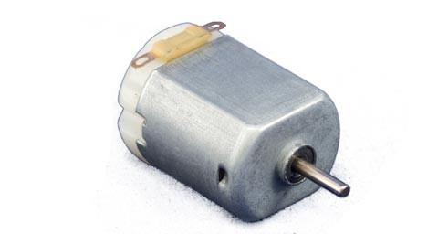

Small DC motor, 0.5-6 volt (3)

1. **10K ohm potentiometer**

A potentiometer is a three-terminal resistor with a sliding or rotating contact that forms an adjustable voltage divider. If only two terminals are used, one end and the wiper, it acts as a variable resistor or rheostat. We can vary the speed with a simple potentiometer. We are using a power source with a low impedance, and motor has also low impedance.

A potentiometer is a three-[terminal](https://en.wikipedia.org/wiki/Terminal_(electronics)) [resistor](https://en.wikipedia.org/wiki/Resistor) with a sliding or rotating contact that forms an adjustable [voltage divider](https://en.wikipedia.org/wiki/Voltage_divider). If only two terminals are used, one end and the wiper, it acts as a variable resistor or [rheostat](https://en.wikipedia.org/wiki/Potentiometer#Rheostat).

The measuring instrument called a [potentiometer](https://en.wikipedia.org/wiki/Potentiometer_(measuring_instrument)) is essentially a [voltage divider](https://en.wikipedia.org/wiki/Voltage_divider) used for measuring [electric potential](https://en.wikipedia.org/wiki/Electric_potential) (voltage); the component is an implementation of the same principle, hence its name.

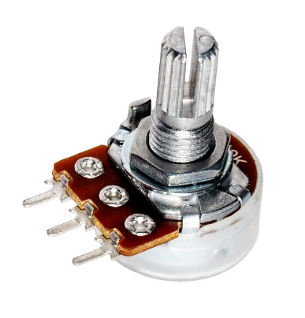

10K Ohm Potentiometer (4)

1. **Breadboard-friendly SPDT Slide Switch**

These slide switches are perfect for use. The 0.100″ pitch means the switch is compatible with solderless breadboards as well as protoboards and perf-boards. Work great as on/off switches or selector switches. The two outer pins are switched while the middle pin is “common”. The small size of just 11.9 x 4.2mm means these can be fit into most projects with ease!

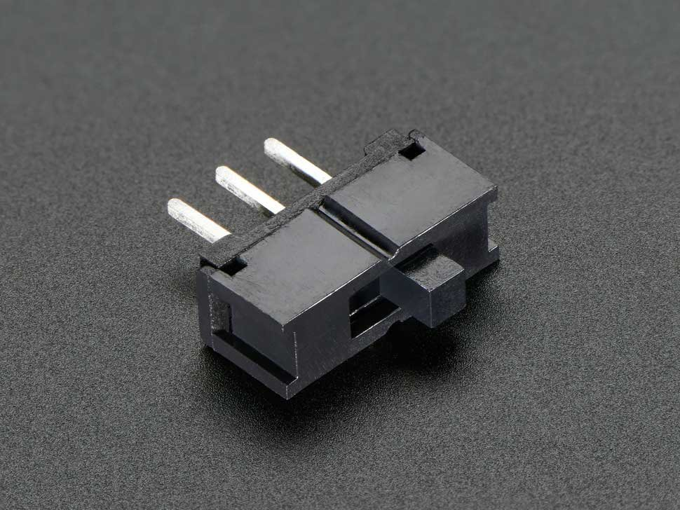

Breadboard-friendly SPDT Slide Switch (5)

1. **Veroboard**

Veroboard is a brand of stripboard, a pre-formed circuit board material of copper strips on an insulating bonded paper.

As with other stripboards, in using Veroboard, components are suitably positioned and soldered to the conductors to form the required circuit. Breaks can be made in the tracks, usually around holes, to divide the strips into multiple electrical nodes enabling increased circuit complexity.

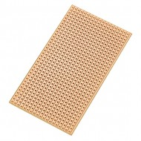

Veroboard Stripboard PCB Board (6)

1. **Jumper wires**

Jumper wires are simply wire that have connector pins at each end, allowing them to be used to connect two points to each other without soldering. Jumper wires are typically used with breadboards and other prototyping tools in order to make it easy to change a circuit as needed.

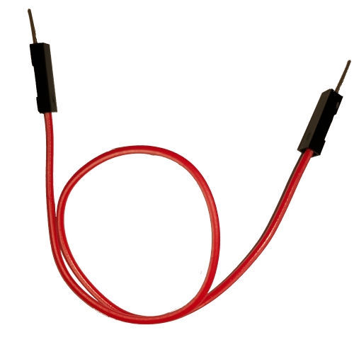

Male to Male Jumper Wire (7)

**CHAPTER III**

* + 1. **Circuit Schematic Diagram**

**[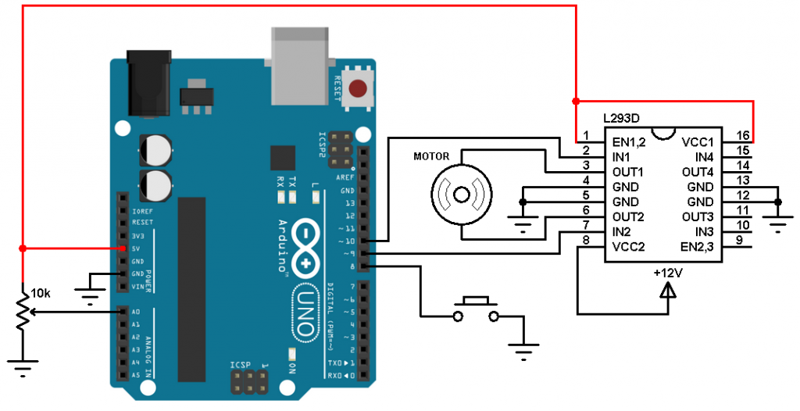](https://simple-circuit.com/wp-content/uploads/2017/12/arduino-dc-motor-control-l293d.png)**

**3.1.2 WORKING of Circuit diagram**

DC motors will have two leads that can be directly attached to a battery or power supply of sufficient capacity. The side of the motor that is connected to the positive of the power source will determine which way the motor rotates.

We will be going a step further than this and using a motor controller called an H-Bridge. Rather than having to unplug the motor to reverse it, this clever chip allows us to reverse the polarity to the motor using logic level signals from a microcontroller. The motor can be run in each direction on command. The chip does all of the heavy lifting and can be directly connected to the DC motor and the Arduino, no additional parts are required.

We need only 3 Arduino terminal pins, pin 8 is for the push button which toggles the motor direction of rotation. Pins 9 and 10 are PWM signal outputs, at any time there is only 1 active PWM, this allows us to control the direction as well as the speed by varying the duty cycle of the PWM signal. The active PWM pin decides the motor direction of rotation (one at a time, the other output is logic 0).

**3.1.3 Index**

**ARDUINO CODE**

|  |  |
| --- | --- |
| **1**  **2**  **3**  **4**  **5**  **6**  **7**  **8**  **9**  **10**  **11**  **12**  **13**  **14**  **15**  **16**  **17**  **18**  **19**  **20**  **21**  **22**  **23**  **24**  **25**  **26**  **27**  **28**  **29**  **30**  **31** | // Arduino DC motor speed and direction control  #define button   8  #define pot      0  #define pwm1     9  #define pwm2    10  booleanmotor_dir = 0;  int motor_speed;  void setup() {  pinMode(button, INPUT_PULLUP);  pinMode(pwm1,   OUTPUT);  pinMode(pwm2,   OUTPUT);  }  void loop() {  motor_speed = analogRead(pot) / 4;  if(motor_dir)  analogWrite(pwm1, motor_speed);  else  analogWrite(pwm2, motor_speed);  if(!digitalRead(button)){                // If direction button is pressed  while(!digitalRead(button));           // Wait until direction button released  motor_dir= !motor_dir;                // Toggle direction variable  if(motor_dir)  digitalWrite(pwm2, 0);  else         digitalWrite(pwm1, 0);     }  } |

Now that all of the code has been written it can be uploaded to our Arduino. Click “Upload” button in the top left corner of the Arduino and it should upload without any issues. Plug the motor power supply in so the motor has power and after a few seconds try adjusting the potentiometer to adjust the motor speed. When changing directions, ensure the motor is stopped as it is not a good idea to reverse the polarity of a motor while running. Going forward, code could be added to this to prevent the user from changing direction unless the throttle is at 0.

* + 1. **Implementation**

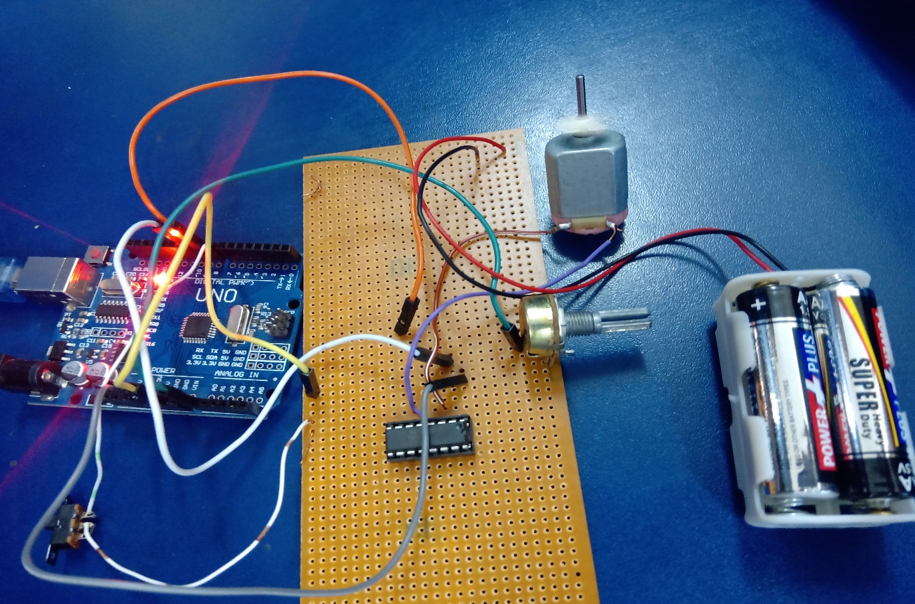

Veroboard Implementation

**CHAPTER IV**

* + 1. **Future Recommendation**

This hardware and code can be adapted to make a small driving robot. So we can say that there will be a future scope in field of power robotics.

This device can be integrated with robotics, drones, cameras, house doors, lockers, smart systems and buildings. Using pulse width modulation output of an Arduino microcontroller controls the speed of dc motor that simulates a treadmill machine.

* + 1. **Conclusion and Result**

The project is purposed on the working of Arduino and L293D IC due to this the cost of the project is not high. It is easy method to control the speed of dc motor.

We demonstrate and integrated system which consists of electrical, electronics, programming. Arduino compiler was used to operate and control the switching actions of dc motor. The speed of dc motor varies from maximum to minimum and also the direction of dc motor is changed.

* + 1. **References**

1. <https://www.theengineeringprojects.com/product/arduino-uno-r3-pakistan>
2. <https://www.robotics.org.za/L293D-DIP>
3. <https://www.goscientist.com/products/small-dc-motor-0-5-6-volt>
4. <https://www.atomsindustries.com/p1046>
5. <https://www.exp-tech.de/en/accessories/buttonsswitches/5114/breadboard-friendly-spdt-slide-switch>
6. <https://www.mreeco.com/veroboard-stripboard-pcb-board-small-in-pakistan>
7. <https://www.faranux.com/product/male-male-jumper-wire-20cm/>
8. <https://learn.adafruit.com/adafruit-arduino-lesson-15-dc-motor-reversing/arduino-code>
9. <https://www.bc-robotics.com/tutorials/controlling-dc-motor-arduino/>
10. <https://simple-circuit.com/arduino-dc-motor-speed-direction-control-l293d/>
11. <https://www.electronicshub.org/speed-and-direction-control-of-dc-motor-using-arduino/>
12. <https://www.youtube.com/watch?v=v2u69O6kZ88>